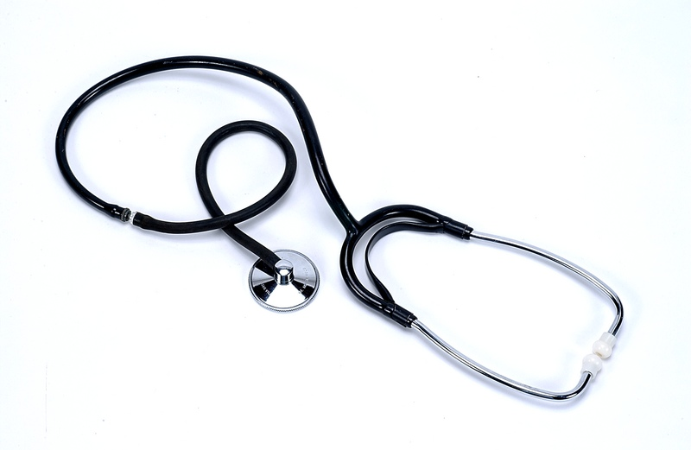
Ann Price 120 1st Avenue.  Sometown, NSW  0400 000 000 name@somedomain.com
Certified Medical Assistant

CMA with experience in a multiphysician family medical practice and additional healthcare experience as an RPT. Known for dedication to providing premium patient care. Skills include:

— Medical Office Management  — Medical Billing & Coding  — Medical Records Management  — Data Entry (75 WPM) | — Bookkeeping & Filing  — Taking Patient Vitals  — Blood Draws  — Injections | — Patient Scheduling  — Ancillary Testing  — Patient Education  — HIPAA & JCAHO Knowledge

Education
Certified Medical Assistant (CMA), 2006-Present
Registered Phlebotomy Tech (RPT), 2004-Present
Certified in First Aid & CPR, 2004-Present

High School Certificate, SOMETOWN HIGH SCHOOL, Sometown, NSW 2000

Professional Experience
ABC FAMILY MEDICAL PRACTICE, Sometown, NSW
Certified Medical Assistant, 2006-Present
Serve as a key member of interdisciplinary healthcare team for a busy family medical practice. Assist seven MDs as well as PA and RN team in ensuring optimal patient care and smooth daily functioning of office. Key Results:
- Consistently praised for efficient handling of administrative duties (e.g., answering phones, scheduling appointments, maintaining medical records, patient processing, billing and bookkeeping) that allowed
doctors and nursing staff to focus on the health concerns of their patients.
- Demonstrated proficiency in taking patient medical histories and vital signs, as well as in performing venipunctures, injections and various diagnostic procedures and ancillary tests (e.g., EKGs, immunoassays, chemistry analysis, hematology, urinalysis and sigmoidoscopies).
- Ensured the cleanliness, sanitation and maintenance of all facilities, exam rooms and equipment.
- Helped implement practice’s quality assurance and control program. Efforts ensured compliance with HIPAA, CLIA and OSHA regulations; improved patient care/satisfaction; and lowered monthly overhead by 12%.
- Reacted calmly and effectively in emergency situations, and added the personal, caring touch that immediately put patients at ease.

XYZ CLINIC, Sometown, NSW
Registered Phlebotomy Technician, 2004-2006
Collected patient blood samples in a safe, sanitary manner for diagnostic testing as a certified phlebotomist.

“…Ann continues to be a vital member of our healthcare team…possesses exceptional patient-care skills…strong command of basic medical procedures and terminology…well-organised and efficient…her cost-saving efforts have saved the practice thousands of dollars annually…one of the finest medical assistants I have worked with throughout my 18-year career as a physician…” — R. Rhasad, MD, ABC Family Medical Practice

